**Auto Generating Records**

1. It is possible to get sites online that will allow you to auto generate data. These are usually free up to a certain amount of records, but by redoing the same procedure with subtle changes it is possible to create many thousands of unique records without having to manually insert them.
2. The sites are:
   1. **Mockaroo:** https://www.mockaroo.com/
   2. **Auto Generator:** http://www.generatedata.com/
   3. **Generate Test Data:** http://www.databasetestdata.com/
3. My preference here is ‘b’ above but you can use the site of your choice.
4. **See screen shot below -**
   1. When you create a dataset it will be downloaded to your Downloads folder and named something like this “dataSep-12-2016.sql” (Assume the Sep will change depending on the Month created.
   2. Once you have this just open MySQL Workbench:
      1. **Select your Database**
         1. Under File on the Menu – select “Open Script File”
         2. Navigate to your file and select “Open”
         3. This will bring the contents into the query window. (It will be all in one line so you will not see it all on screen. You can select the “Toggle/Wrap” icon on the menu bar but for large files it does not recommend this.
         4. Press CNTRL&A to select all and run
         5. Note: It is best to have the Table created and empty when carrying out this operation.
      2. Then you can simple run the Generator again and make some changes:
         1. Ensure the PK starts at the last record entered + 1 as this will not accept duplicates.
         2. If you have FK’s that wish to be different as in county_id then simple add the number Id you want for this run.
         3. The text data as in names will change every time

Sample for the table customers:

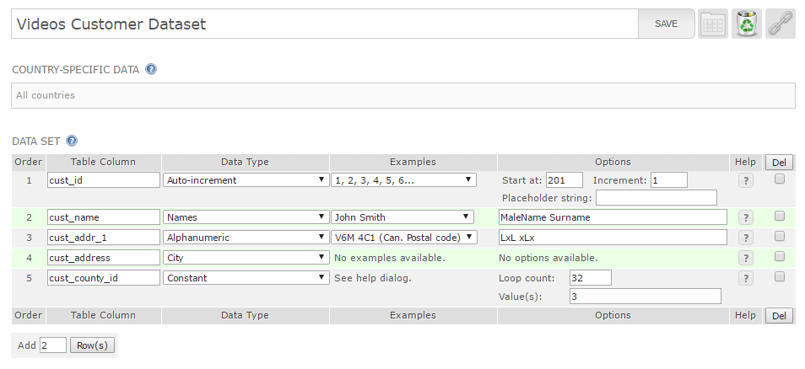

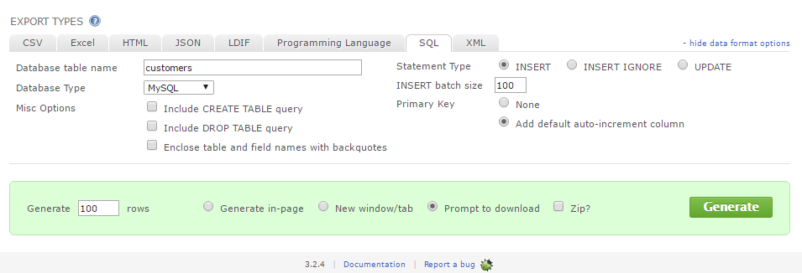

**SELECT Statements to check your progress**

These are some simple statements to check the status of your loads:

1. While loading 100 records at a time this will allow you to check for different FK’s on county_id field for example:
2. SELECT * FROM customers WHERE cust_id in (1,101, 201);
3. This is the output:

|  |  |  |  |  |
| --- | --- | --- | --- | --- |
| cust_id | cust_name | cust_addr_1 | cust_address | cust_county_id |
| 1 | Barclay Sanchez | I1L 3I9 | Clermont-Ferrand | 1 |
| 101 | Callum Watts | B5G 8J6 | Kavaratti | 2 |
| 201 | Chancellor Golden | Q7S 1K3 | Sundrie | 3 |
|  |  |  |  |  |

1. To keep a track on the number of records loaded:
   1. SELECT COUNT(*) FROM customers;
   2. This is the output:
   3. COUNT(*)
   4. 300
   5. To check for duplicates you can enter:
   6. SELECT COUNT(*), cust_name FROM customers GROUP BY cust_name HAVING COUNT(*) > 1 ;
   7. If all is OK this will return no records

**Using SQL and Stored Procedures to generate Data**

1. Manual Process 9Only recommended for small amounts of records)
2. **/* Manually Creating Transaction Records for the Orders Table */**
   1. /* Run the below once to get an initial record in the table */
   2. INSERT INTO orders (ord_id, cust_id, ord_date)

VALUES (1, 1, '2014-07-01');

* 1. **/* Now run this many times to add more records for Cust_id = 1, this will add a new record starting from 2nd July 2014 one day at a time */**
  2. INSERT INTO orders (ord_id, cust_id, ord_date)

SELECT max(ord_id + 1),

cust_id,

Max(date_add(ord_date,INTERVAL 1 DAY))

FROM orders

WHERE cust_id = 1;

1. **/* Now change Insert “b” above to cust_id = 2 as in ( 1, 2, ‘2014-07-01’) and run once only , then change the cust-id in Insert “d” to 2 and run many times again. */**
2. **/* Repeat these steps for every cust_id you have in tour Customer table */**
3. **Using Stored Procedures (Recommended way for large amounts of data)**

CREATE DEFINER=`root`@`localhost` PROCEDURE `para_loadTrx_wp`(IN cust_id int(11))

BEGIN

declare loadAmt int;

declare orddate date;

set loadAmt = 1;

set orddate = '2014-07-01';

/* Ensure the ord_id Field is AUTO_INCREMENT */

WHILE loadAmt <= 10000 DO

INSERT INTO orders (ord_date, cust_id )

SELECT orddate,

cust_id

FROM dual;

set loadAmt = loadAmt + 1;

set orddate = date_add(orddate,INTERVAL 1 DAY);

END WHILE;

END

To call this use the following:

CALL para_loadTrx_wp(1);

CALL para_loadTrx_wp(2);

CALL para_loadTrx_wp(3);

Then you can add 4, 5 6 etc until you have covered every Customer you have.

Note: Might be good to change the Loadamt variable and the date variable to have different amounts for each day etc. Also might want to remove Xmas day etc when complete?